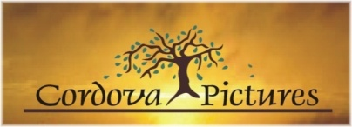
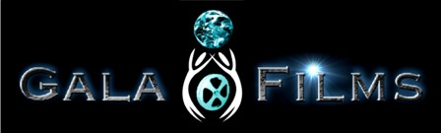


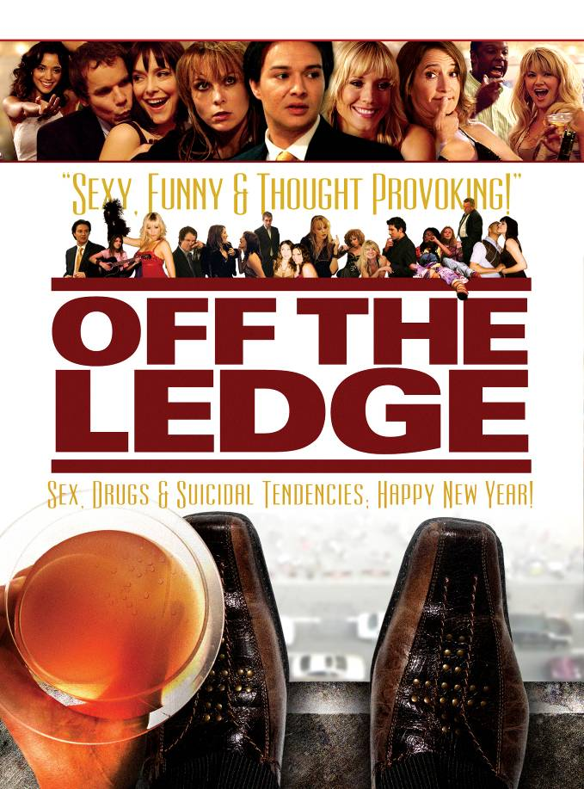

THE CAST

www.offtheledgemovie.com

Available on DVD – 22nd December, 2009

FOR PRESS - M4 CONSULTANTS  Melanie Marquez / Sr. Publicist  PH: + 1-626-833-6790  publicity@M4PIPS.com | CORDOVA PICTURES  PH: + 1-323-876-7252  5419 Hollywood Blvd. Suite C #175  Hollywood, CA 90027  info@cordovapictures.com
Running Time: 89mins Shooting Format: HD Viper Camera Sound: Dolby 5.1 Surround
For more information and artwork on this release please visit www.offtheledgemovie.com/EPK



ABOUT THE CAST
JUSTIN WHALIN as ‘Hopper’

Best known for his portrayal of the young journalist Jimmy Olsen in the long-running series “Lois and Clark - The Adventures of Superman” and as Ridley in New Line Cinema’s “Dungeons and Dragons”.
At 13, Justin’s first television role was portraying the spoiled, bratty Alan Quatermaine Jr. on Daytime’s “General Hospital ”. He then went on to star in the sitcom “Charles in Charge,” The Disney Channel’s “Perfect Harmony,” & the CBS sitcom “It Had To Be You” opposite Faye Dunaway. Justin also had starring roles in the John Waters film “Serial Mom” with Kathleen Turner, “Susie Q,” and “Miracle at Midnight” opposite Mia Farrow and Sam Waterston. Justin won an Emmy for his depiction of a son with lesbian parents in the ABC after school special “Other Mothers”.
Most recently he can be seen in “Super Capers”.

ANNE RAMSAY as ‘Bonnie’

Anne was inspired at an early age by Barbra Streisand's performance in the feature film "Funny Girl", which eventually led her to study theater at UCLA. After graduation, her work in The Continuum, an acting group she formed with fellow UCLA alumni, provided her with her first real break. Their ‘87 stage production of "Waiting," which she co-wrote, won the group acclaim, awards, and Ramsay an agent.
Ramsay went on to star in numerous TV shows and films, in both comedy and drama, with her first projects being rare and amazing experiences: Penny Marshall's "A League of Their Own" and the NBC hit comedy "Mad About You". She has appeared in "CSI", "Without A Trace", Showtime's ground-breaking drama "The L Word" and HBO's "Six Feet Under". She has worked on big budget feature films including Tim Burton's "Planet Of The Apes" as well as various indie projects, and a slew of television appearances including: Close To Home" HBO’s Tell Me You Love Me", the award-winning “House", ABC’s new hit “Castle”, a recurring role on “Dexter” and can currently be seen in “Hawthorne”.

BROOKE ‘MIKEY’ ANDERSON as ‘Kat Clifton’

Award Winning Australian Actress, Brooke won international acclaim when she was just six years old, with her portrayal as the young make believe mother in the hard hitting cubby house, drug abuse commercial that won awards all over the world.
With a leading regular role in television’s Logie award winning series “EStreet”; a nomination for the prestigious Penguin Award for Best Performance by a Juvenile; and winner of the Variety Club Award for Most Outstanding Juvenile Actress, Brooke proved herself to be one of Australia’s most popular young actors, starring in numerous Australian Television Shows, including “Ocean Girl” and her own series “Glad Rags.”
Recently, Brooke Co-Starred on ABC’s Hit TV series “Lost”, FOX’s Sitcom “Happy Hour”, and has lead the cast of numerous Independent Feature Films, most recently joining the cast of “Perfect Host” with Helen Reddy & David Hyde Pierce.

NECTAR ROSE as ‘Carrie Clifton’

Nectar can often be seen at world-wide Sci-Fi conventions continuing to address the fans of the cult movie “Serenity” where she portrayed The Miss Universe ‘Love Bot’ “Lenore”.

She played Marilyn Monroe in “LA Confidential”, and can be seen in such films as: “Independence Day”, “Bring it On”, “Legally Blonde”, “50 First Dates”, “Bad News Bears”, “Brothers Solomon” and recently starring alongside Christopher Walken in “$5 a day” ; as well as numerous TV shows like: “Two and a Half Men” and “That 70’s Show”.

NATHAN BAESEL as ‘Boston’

Nathan starred as serial killer Leslie Vernon in the indie cult/horror “Behind The Mask: The Rise of Leslie Vernon". He is also well known for his portrayal of the recurring, innocent Deputy Lewis Sirk, to William Fichtner's mysterious Sheriff, on the TV Series "Invasion."

With numerous Guest Appearances on shows like "Without A Trace," "Cold Case,", “CSI”, “Numb3rs”, “The District", and “Journeyman”; Nathan is also a popular theater actor on both coasts of the USA; graduating from 'The Juilliard School of Drama' and receiving a BA in Theatre from UCLA. He is also a founding member of NY-based Theater Mitu and he performs regularly for the South Coast Repertory. He will soon be seen in the Indie sci-fi “20 Years After” starring alongside Azura Skye.

JENNY MOLLEN as ‘Amber-Elizabeth’

Jenny has a large cult following for her recurring role as Nina Ash on the hit TV Series "Angel."
Recently Jenny has been recurring on the Starz series “Crash” and has had Guest starred on such shows as “Strong Medicine” & “Medium”. Jenny can also be seen in “National Lampoon's Cattle Call”, “Return of the Living Dead: Rave to the Grave”, “The Raven”, “D.E.B.S” and alongside Tom Sizemore in “Ring Around the Rosie” and alongside her recent husband Jason Biggs, Kate Hudson & Dane Cook in Lionsgate’s “My Best Friend’s Girl”.
Jenny is also a prominent artist exhibiting her work throughout London, NY and LA.

RAYMOND O’CONNOR as ‘Richard “Dick” Buchman’

Widely recognized for his commercial work (even more so his infamous Emmy nominated American Express commercials); he has also been described by media as the consummate character actor and scene stealer. Ray has acted alongside the best; George Kennedy (“Sands Of Oblivion”); Tony Shaloub (“Monk”); Sam Shepard (“Don't Come Knocking”); Reese Witherspoon and Mark Ruffalo (“Just Like Heaven”); Danny Devito, Bette Midler, Jamie Lee Curtis (“Drowning Mona”); Billy Crystal (“My Giant”); Ed Harris, Nicolas Cage, and Sean Connery (“The Rock”); Bruce Willis (“Breakfast of Champions”); Mel Brooks (“Life Stinks”)…and the list is endless!
He's made unforgettable appearances on shows like “Medium” "C.S.I.” “Monk”; "The Handler”; "NYPD Blue”; "Boomtown”; "Six Feet Under”; "Buffy The Vampire Slayer”; “Becker”; "Babylon 5”; "Wings”; and a recurring role on "Beverly Hills 90210” amongst numerous others.

YAN FELDMAN as ‘Richard “Dick” Buchman’

Canadian born, Yan has had numerous Guest roles on such shows as: "Relic Hunter", and "Queer as Folk".
With a recurring role on "Stargate SG-1", Yan also has a cult following from Joss Whedon’s popular Sci-Fi movie “Serenity” and from playing Dr. Dark in “Who wants to be a Super Hero”. Yan’s latest films have been “Chasing Tchaikovsky” & “Stone & Ed”.

MARIA CINA as ‘Vera’

Described as "outstanding" by Ed Kaufman of the Hollywood Reporter. Born in Buffalo, New York, Maria began her career as a teenage dancer, performing internationally with artists like Prince, Reba Mac Entire and Tina Turner and Barry White. After moving to Los Angeles, Maria began to study acting with Stella Adler and landed her first television role on “Beverly Hills 90210”.
The independent feature film “April’s Shower” that Maria also Co-Produced earned her a cult following, and her performance in “Dog Story” won her a nomination for best actress at Method Fest. Other features include: “Falling Up”, “Suspended Animation”; “Wild Things 2: Diamonds In The Rough”; “This Girl's Life”; “Ant” (Tribeca, Festival du Court Metrage); “The Amati Girl’s”, “Vegas Vacation”, “The Mask”, “The Gentleman Bandit” and “Brahm Stoker’s Dracula”. Maria has also Guest Starred on numerous Television shows, such as: “Seinfeld”; “3RD Rock from the Sun”; “The Young and the Restless”; “Wings”; and “Baywatch”.

ANDREA DE OLIVEIRA as ‘Maia’

Has numerous Guest Star appearances on such TV shows as: “Cold Case”; “CSI”; “CSI Miami”; “My Name is Earl”; “Still Standing”, “Secret Girlfirend”, “Community” and a recurring role on “Kingpin”. She can also be seen in the Feature Film “Loveless in Los Angeles” and alongside Ben Stiller in “Tropic Thunder”
A Brazilian dancer, Andrea was one of the original members of the 'Fantanas' in 2002 playing the character of 'Raquel' dressed in a purple outfit to sell 'Fanta' grape soda.

ANDREW PIÑON as ‘Aaron’

Andrew is a graduate from UCLA’s School of Theater Film and Television.
On stage, he has performed lead roles in productions of Hamlet, One Flew over the Cuckoo’s Nest, The Complete Works of William Shakespeare (Abridged), and The Crucible. On film, Andrew has appeared in the feature comedy “Diamonds and Guns,” the gritty drama “Los Jornaleros,” and the Sci-Fi Thriller “Socket.” and recently landed the role of “Paco” in the pilot episode of the upcoming television crime drama “Underbelly.”
Andrew has performed improvisational Dinner Theater with Gourmet Detective in Irvine, California from 1997-2001. From there, Andrew brought his improvisational talents to the Comedy Troupes, “Loosely Based” and “AB3” in Hollywood and most recently is performing with the “Captains of Industry”.

BREE SHARP as ‘Janice’

While still in college, Bree began writing the songs that eventually lead to her 1998 record deal with Trauma Records. In ‘99, she released her first album, A Cheap and Evil Girl, to strong critical reviews. The album's first single, "David Duchovny" quickly garnered a cult following both for its musical qualities and its tie-in to the popular X-Files TV series.
In 2001, Bree Sharp left Trauma Records and her next album, More B.S., was self-released on her own label Ahimsa Records. In 2004, she released Live at Fez , a live concert album performed in New York .Bree is reportedly working as writer on a Fox Saturday morning anime cartoon show entitled “Magical DoReMi” and also contributed to the English Pok’n dub with her song This Side of Paradise in the “Destiny Deoxys” movie.

ALEX PETROVITCH as ‘Bob’

Takes a comedic turn in "OFF THE LEDGE " from his dramatic performances in the mega hit t.v. series "Lost," his upcoming role in “24”, the cult Horror film "Bled," "Passage to Zarahemla", "Down In New Orleans" and has been a regular on the daytime soap operas "The Bold and The Beautiful" and "Passions."
Alex has worked on several daytime dramas, nighttime episodics, independent films, and a handful of commercials, he can most recently be seen in “The Intruders” alongside Steven Bauer, and “American Cowslip” with Diane Ladd, Peter Falk, Bruce Dern and Val Kilmer.

ZOSIA MAMET as ‘Jamie’

With a name like Mamet, you’d be surprised if talent didn’t run in the family. Zosia is an up and coming young actress who has had a recurring role on “The Unit”, and can also be seen in the feature films “Spartan” and “Colin Fritz”. Her latest films “Cherry” & the “Untitled Duplass Brothers Project” will be out for release in 2010 where she joins the cast alongside Marissa Tomei, John C. Reilly, Catherine Keener & Jonah Hill.

CARLEE AVERS as ‘Debbie’

Well known for her recurring role on the hit WB / CW series "Veronica Mars" she also starred in the very scary "Are You Scared" in addition to appearing on the series "Commander In Chief" with Geena Davis and Donald Sutherland. She can also be seen in: “Jekyll”, “Over the Line” and “Back at the Ranch” and the TV Movie from Sony Pictures and A&E - “Danny Fricke”. Carlee will also be seen in the 2010 film “Family Wedding” alongside America Ferrera, Forrest Whitaker, Taye Diggs & Regina King.

JAMES FERRIS as ‘David’

James has starred in the horror film “The Hitchhiker” as well has having Guest Starred in numerous shows such as: “CSI: NY”, “Cold Case”, “Las Vegas”, Prison Break” & “Knight Rider”.
He can also be seen in “Jacqueline Hyde”, “Nite Tales”, “Pirates of Treasure Island”, “King of the Lost World”, and “Pretty Cool 2” and can be seen in the recent Universal Picture “Couples Retreat”.

FAY WOLF as ‘Fuck Off Chick’

Guest starred on numerous series; “Bones”, “Numbers”, “Chappelle's Show”, “The Guiding Light”, “The Education of Max Bickford”, “Law & Order” , “NCSI: Los Angeles”, and had a recurring role on “All My Children” and more recently “Terminator: The Sarah Connor Chronicles”.
Fay is also a singer with her first EP having just been released in Nov ’09.

JOESEPH PORTER as ‘Tony’

Studied acting at the Moscow Art Theatre and Depaul University before graduating summa cum laude with his BFA from Wayne State University, Joseph has Co-Starred on “Wizards of Waverly”, “Off Campus” & “Ugly Betty”; he can also been seen in such films as “Remembrance” and “Gingerdead Man 2”.
In addition to playing the lead in numerous theater productions, Joseph also plays guitar in the band "Hot Carl and The Cleveland Steamers".

